**EXPERIMENT NO.11**

Study of Arduino board and understand the OS installation process on Raspberry-pi.

**Aim:**Study of Arduino board and understand the OS installation process on Raspberry-pi.

**Software requirement:**

* Microsoft® Windows® 10/8/7 64−bit
* Arduino IDE
* Raspbian

**Hardware requirement:**

* USB connecting cable
* Arduino UNO board
* Raspberry-Pi:

**Theory:**

We will study the Arduino UNO board because it is the most popular board in the Arduino board family. In addition, it is the best board to get started with electronics and coding. Some boards look a bit different from the one given below, but most Arduinos have majority of these components in common.

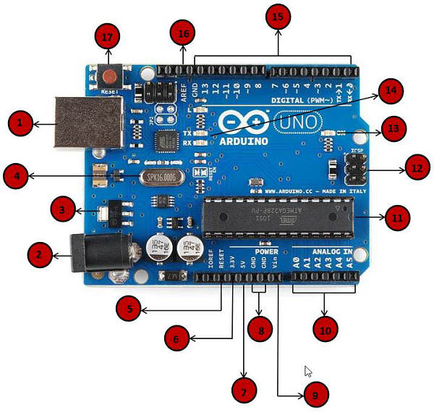

|  |  |
| --- | --- |
| Power USB | **Power USB**  Arduino board can be powered by using the USB cable from your computer. All you need to do is connect the USB cable to the USB connection (1). |
| Barrel Jack | **Power (Barrel Jack)**  Arduino boards can be powered directly from the AC mains power supply by connecting it to the Barrel Jack (2). |
| Voltage Regulator | **Voltage Regulator**  The function of the voltage regulator is to control the voltage given to the Arduino board and stabilize the DC voltages used by the processor and other elements. |
| Crystal Oscillator | **Crystal Oscillator**  The crystal oscillator helps Arduino in dealing with time issues. How does Arduino calculate time? The answer is, by using the crystal oscillator. The number printed on top of the Arduino crystal is 16.000H9H. It tells us that the frequency is 16,000,000 Hertz or 16 MHz. |
| Arduino Reset | **Arduino Reset**  You can reset your Arduino board, i.e., start your program from the beginning. You can reset the UNO board in two ways. First, by using the reset button (17) on the board. Second, you can connect an external reset button to the Arduino pin labelled RESET (5). |
| Pins | **Pins (3.3, 5, GND, Vin)**   * 3.3V (6) − Supply 3.3 output volt * 5V (7) − Supply 5 output volt * Most of the components used with Arduino board works fine with 3.3 volt and 5 volt. * GND (8)(Ground) − There are several GND pins on the Arduino, any of which can be used to ground your circuit. * Vin (9) − This pin also can be used to power the Arduino board from an external power source, like AC mains power supply. |
| Analog pins | **Analog pins**  The Arduino UNO board has six analog input pins A0 through A5. These pins can read the signal from an analog sensor like the humidity sensor or temperature sensor and convert it into a digital value that can be read by the microprocessor. |
| Main microcontroller | **Main microcontroller**  Each Arduino board has its own microcontroller (11). You can assume it as the brain of your board. The main IC (integrated circuit) on the Arduino is slightly different from board to board. The microcontrollers are usually of the ATMEL Company. You must know what IC your board has before loading up a new program from the Arduino IDE. This information is available on the top of the IC. For more details about the IC construction and functions, you can refer to the data sheet. |
| ICSP pin | **ICSP pin**  Mostly, ICSP (12) is an AVR, a tiny programming header for the Arduino consisting of MOSI, MISO, SCK, RESET, VCC, and GND. It is often referred to as an SPI (Serial Peripheral Interface), which could be considered as an "expansion" of the output. Actually, you are slaving the output device to the master of the SPI bus. |
| Power LED indicator | **Power LED indicator**  This LED should light up when you plug your Arduino into a power source to indicate that your board is powered up correctly. If this light does not turn on, then there is something wrong with the connection. |
| TX and RX LEDs | **TX and RX LEDs**  On your board, you will find two labels: TX (transmit) and RX (receive). They appear in two places on the Arduino UNO board. First, at the digital pins 0 and 1, to indicate the pins responsible for serial communication. Second, the TX and RX led (13). The TX led flashes with different speed while sending the serial data. The speed of flashing depends on the baud rate used by the board. RX flashes during the receiving process. |
| Digital I/O | **Digital I/O**  The Arduino UNO board has 14 digital I/O pins (15) (of which 6 provide PWM (Pulse Width Modulation) output. These pins can be configured to work as input digital pins to read logic values (0 or 1) or as digital output pins to drive different modules like LEDs, relays, etc. The pins labeled “~” can be used to generate PWM. |
| AREF | **AREF**  AREF stands for Analog Reference. It is sometimes, used to set an external reference voltage (between 0 and 5 Volts) as the upper limit for the analog input pins. |

Arduino: - The Arduino itself has no real operating system. You develop code for the Arduino using the Arduino IDE which you can download from Arduino - Home. Versions are available for Windows, Mac and Linux. The Arduino is a constrained microcontroller.

Arduino consists of both a physical programmable circuit board (often referred to as a microcontroller) and a piece of software, or IDE (Integrated Development Environment) that runs on your computer, used to write and upload computer code to the physical board. You are literally writing the "firmware" when you write the code and upload it. It's both good and its bad.

**Raspberry-Pi:**

The Pi can run the official Raspbian OS, Ubuntu Mate, Snappy Ubuntu Core, the Kodibased media centers OSMC and LibreElec, the non-Linux based Risc OS (one for fans of 1990s Acorn computers). It can also run Windows 10 IoT Core, which is very different to the desktop version of Windows, as mentioned below. • OS which install on Raspberry-Pi: Raspbian, Ubuntu MATE, Snappy Ubuntu, Pidora, Linutop, SARPi, Arch Linux ARM, Gentoo Linux, etc.

**How to install Raspbian on Raspberry-Pi**:

Step 1: Download Raspbian

Step 2: Unzip the file. The Raspbian disc image is compressed, so you’ll need to unzip it. The file uses the ZIP64 format, so depending on how current your built-in utilities are, you need to use certain programs to unzip it.

Step 3: Write the disc image to your microSD card. Next, pop your microSD card into your computer and write the disc image to it. The process of actually writing the image will be slightly different across these programs, but it’s pretty self-explanatory no matter what you’re using. Each of these programs will have you select the destination (make sure you’ve picked your microSD card!) and the disc image (the unzipped Raspbian file). Choose, double-check, and then hit the button to write.

Step 4: Put the microSD card in your Pi and boot up. Once the disc image has been written to the microSD card, you’re ready to go! Put that sucker into your Raspberry Pi, plug in the peripherals and power source, and enjoy. The current edition to Raspbian will boot directly to the desktop. Your default credentials are username pi and password raspberry.

**Conclusion:** Hence, we have studied Arduino board and OS installation procedure of Raspbian.